Registration Instruction

Early registration is now available at the online payment portal of Shanghai Jiao Tong University: http://www.jdcw.sjtu.edu.cn/payment/. Please register first before login into the portal. Once the online payment is completed, receipt can be collected onsite on the first day (13 October 2017) of the conference. For those who choose to make the payment onsite, your receipts will be sent to you through mail (Shung Feng Express) a week later after the conference.
Please be aware that early registration will be available till 1 August 2017.
The online payment can be made through the following steps:
- Login into the online payment portal: http://www.jdcw.sjtu.edu.cn/payment/
- Choose the title “Researching T&I (standard)” or “Researching T&I (student)” of the conference. For university staff, please choose “Researching T&I (standard)”. For students, please choose “Researching T&I (student)”. Then, click on the button “pay” as shown below:

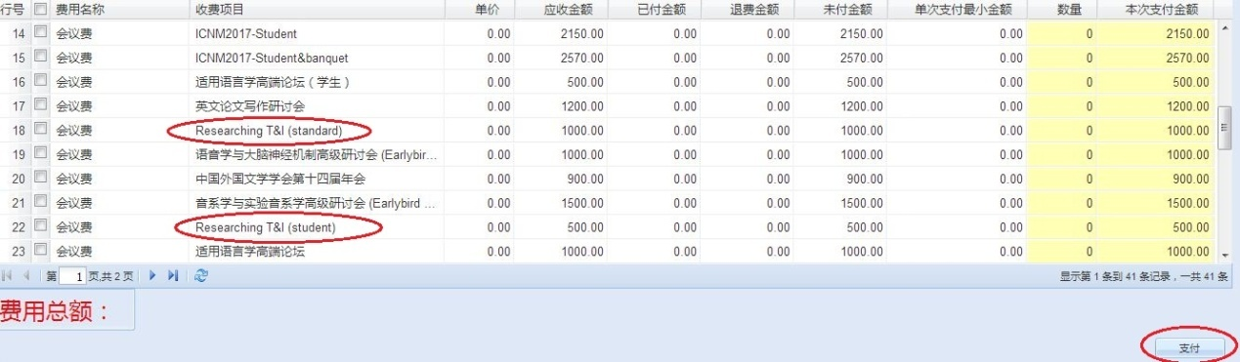

- Please choose one of the payment methods as illustrated in the following page to make your payment:
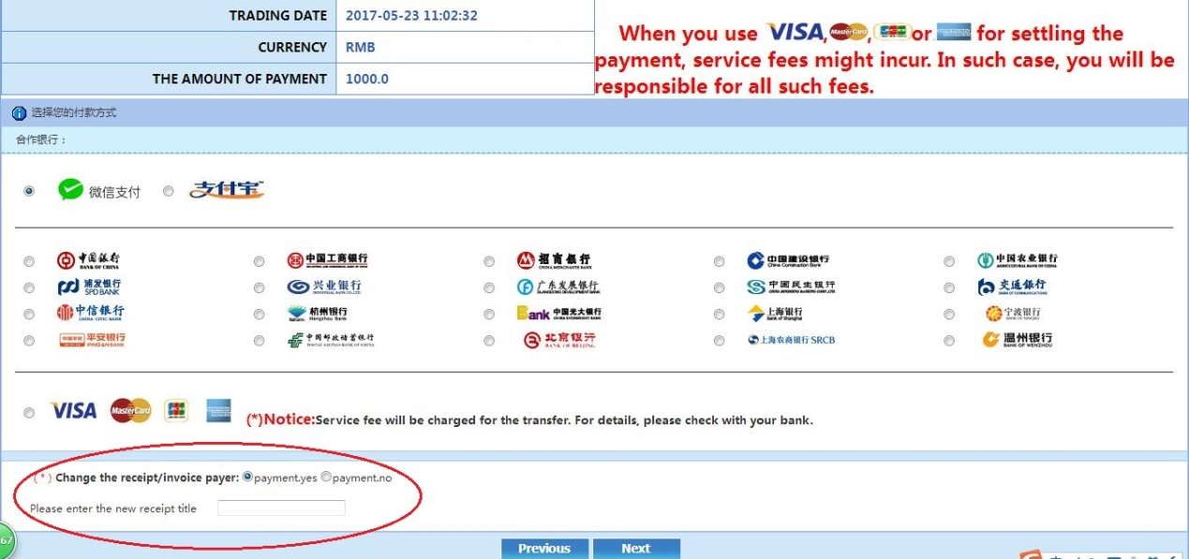
*Notice:
On this page, please click “payment.yes” to enter the name of the receipt/invoice payer, which will be used as the title of your receipt. Otherwise, the title of your receipt will be the username that you use to access this online payment portal. Please be aware that once the receipt is issued, corrections are not possible.
特别注意：在此页面，需要修改缴费单位名称，此缴费单位名称将会作为发票抬头。如不修改，则默认为注册名字。发票一经开出，不退不换。
- Click on “Next” to make the payment.

If you have any questions about using the online payment platform, please contact Dang Li (dangli@sjtu.edu.cn) or Kyung-Hye Kim (kyunghye.kim@sjtu.edu.cn).

